NAME: VENKATARAMAMOORTHY.G
- Create a box that takes up 80% of the screen width but no more than 600px.
The box takes 80% of the screen, so it automatically becomes smaller on phones and smaller devices. At the same time, we set a maximum width of 600px so it doesn’t become too wide on big screens like laptops or desktops. This helps keep the content easy to read.
- Set a paragraph’s font size to 1.5rem and explain how it behaves on different devices.
The paragraph text is set to 1.5rem, which is around 24px. We use rem instead of pixels because it adjusts based on the browser’s settings. So if someone increases their text size, the paragraph will also become bigger, making it easier to read.
- Use vw to make a heading that scales with screen size.
The heading uses vw units, which means its size depends on the screen width. When the screen gets bigger, the heading becomes larger, and when the screen gets smaller, it becomes smaller. This makes the text look good on all devices.
- Write a media query that changes background color below 768px.
We use a media query to apply styles when the screen size is less than 768px. This usually means phones or small tablets. When the screen is smaller than this, the background color changes so the design looks better and more suitable for mobile screens.
CODE:
<!DOCTYPE html>
<html lang="en">
<head>
<meta charset="UTF-8">
<meta name="viewport" content="width=device-width, initial-scale=1.0">
<title>Document</title>
<style>
div{
width: 80%;
max-width: 600px;
background: linear-gradient(90deg, #f8ff00 0%, #3ad59f 100%);
height: 40vh;
border-radius: 8px;
box-shadow: 5px 5px 5px;
padding-left: 20px;
padding-top: 10px;
padding-right: 20px;
text-align: justify;
}
p{
font-size: 1.5em;
color: darkred;
}
h1{
font-size: 5vw;
text-align: center;
color:lightcoral;
}
@media (max-width:768px){
body{
background: linear-gradient(90deg, #00C9FF 0%, #92FE9D 100%);
}
}
@media (min-width:769px){
body{
background: linear-gradient(90deg, #d53369 0%, #daae51 100%);
h1{
color:lightskyblue;
}
}
}
</style>
</head>
<body>
<h1>CSS TASK - 13 </h1>
<hr>
<div class="box">
<p>The box takes 80% of the screen, so it automatically becomes smaller on phones and smaller devices. At the same time, we set a maximum width of 600px so it doesn't become too wide on big screens like laptops or desktops. This helps keep the content easy to read.</p>
</div>
</body>
</html>
OUTPUT: [When with is 768px below]
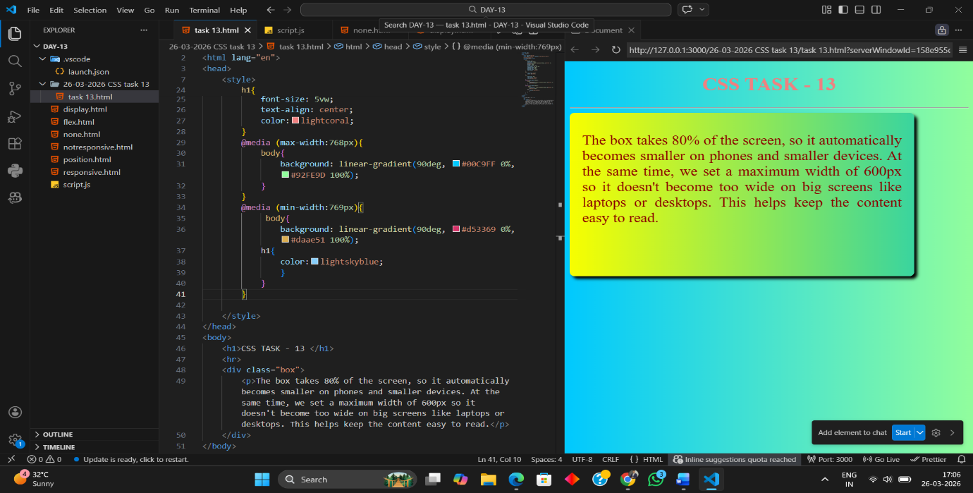
OUTPUT: [When with is 768px above]
